PSY-150
Quantitative Literacy Assignment
Introduction:
This assignment requires you analyze data selected from the article Characteristics of minimum wage workers, 2018 (U.S. Bureau of Labor Statistics, 2019).
This assignment fulfills/supports:
- Module Outcome:
- Course Outcome: 2
- General Education Competencies: 2, 4
The Assignment:
For this Assignment, complete the following steps:
Step 1:
Review Table 6 (attached). This table shows the numbers (and percentages) of hourly workers who earn at or below minimum wage at various levels of education.
Step 2:
Using information found in Table 6 (attached), answer the following questions:
- The table highlights the impact of education on wages. According to the table, what percentage of people with an Associate Degree earn at or below minimum wage?
- What percentage of people with a Bachelor Degree earn at or below minimum wage?
- What factors could explain these percentages?
- According to the table, what is the relationship between educational attainment and the percentage of hourly workers who earn at or below minimum wage?
- Use the chart below to answer the following questions:
  - What is the mean of the minimum wage rates in the 1980s? 1990s? 2000s?
  - What is the range of the minimum wage rates from 1979 until 2009?
  - What is the median of the minimum wage rates from 1979 until 2009?

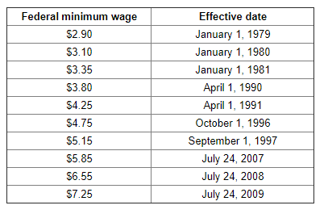
Citing Sources: You must use APA style to reference your source(s) at the end of your submission. For this assignment, you must include reference information for your textbook. Information on how to format reference information (including a reference generator) in APA style can be found on the Purdue Online Writing Lab website at https://owl.purdue.edu/owl/research_and_citation/apa_style/apa_formatting_and_style_guide/general_format.html (opens in a new window).
Acceptable Length: N/A
Formatting Requirements:
- Use 12-point Times New Roman or Arial font
- Use double line spacing in the document
- 1-inch margins all around
Grading criteria: For full points you must fully comply with each component of the Assignment Rubric.
To Submit: Click on the “Quantitative Literacy Assignment” link above. When the new page opens, scroll to the “Assignment Submission” area and click “Browse My Computer”. Attach your document (must be in .doc, .docx, .pdf or .rtf format) and click “Submit”.

